1
* |  | (from) COUNTRY |  | NATIONALITY |  | LANGUAGES
 |  |  | (from) the U.S.A.  (= the United States of America) |  | American
 |  |  | (from) Australia
 |  |  | (from) Colombia |  |  | Spanish
 |  |  | (from) India
 |  |  | (from) Brazil |  | Brazilian
 |  |  | (from) Canada
 |  |  | (from) Italy
 |  |  |  |  | Russian

2
* |  | (from) COUNTRY |  | NATIONALITY |  | LANGUAGES
 |  |  | (from) Great Britain  (= The U.K. = The United Kingdom) |  | British
 |  |  | (from) Finland
 |  |  | (from) Ireland
 |  |  | (from) Poland
 |  |  | (from) Spain
 |  |  | (from) Turkey |  | Turkish

3
* |  | (from) COUNTRY |  | NATIONALITY |  | LANGUAGES
 |  |  | (from) |  | Chinese
 |  |  | (from) Japan
 |  |  | (from) Vietnam
 |  |  |  |  | Portuguese

4
 | (from) France
 | (from) Germany | German
 | (from) |  | Greek
 | (from) | Swiss

My notes

Task
Describe the pictures.
Write where the people are from,
what nationality they are and what languages they speak.

* | (from) COUNTRY | NATIONALITY | LANGUAGES
*  *  *  *  * | I am from …  He is from …  We are from …  You are from …  They are from … | I am …  She is…  We are…  You are…  They are… | I speak …  (S)He speaks …  We speak …  You speak …  They speak …
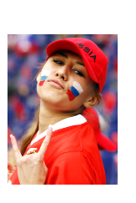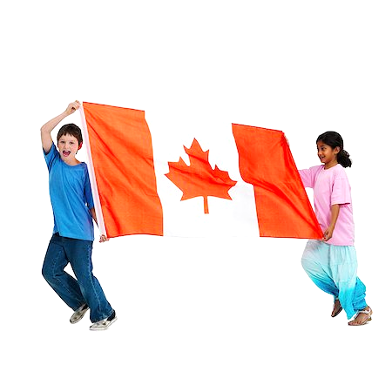
a b c d
EXAMPLE:
e) 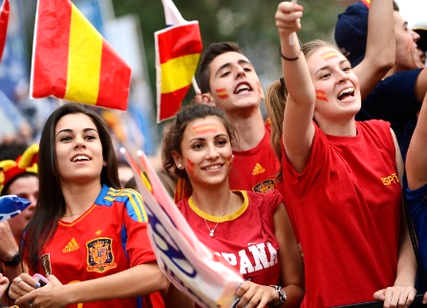
They are from Spain. They are Spanish. They speak Spanish.
a)_________________________________________________________________
b)_________________________________________________________________
c)_________________________________________________________________
d)_________________________________________________________________

Today is Tuesday. It’s the 24th of October.

The topic is _______________________________________________.

I will learn ________________________________________________.

