OUR APPEARANCE
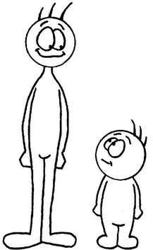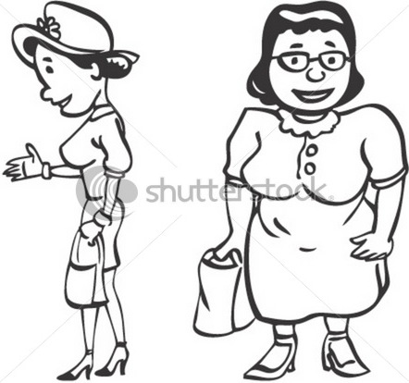
tall short slim fat
I’m tall. = I’m not short. My friend is fat. = She isn’t slim.
We are short. = We aren’t tall. We are young. = We aren’t old.
- - - - - - - - - - - - - - - - - - - - - - - - - - - -
OUR HAIR
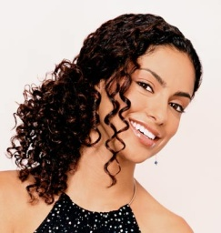She has got long dark curly hair. Her hair is long, dark and curly.
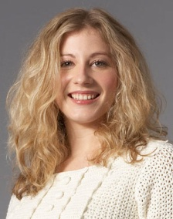 She has got long fair wavy hair. Her hair is long, fair and wavy.
She’s got short blond wavy hair. Her hair is short, blond and wavy.
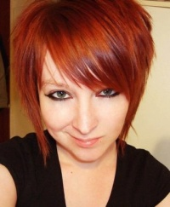She’s got short ginger straight hair. Her hair is short, ginger and straight.
- - - - - - - - - - - - - - - - - - - - - - - - - - - -
What is YOUR hair like?
I’ve got _____________________________________________. My ______________________________________________.

